Proposal

**Roles:**

Database developer the person and exchange data.

My work is described as the process below:

1. Texts on the website -> excel

We may consider ask customers to hand in the texts on the website, then we change it into excel.

By the codes of Python 3.9 below, we can change the *.txt into *.xls.

Module: xlwt, os, sys

Requirements: The files must suit the formats of excel.

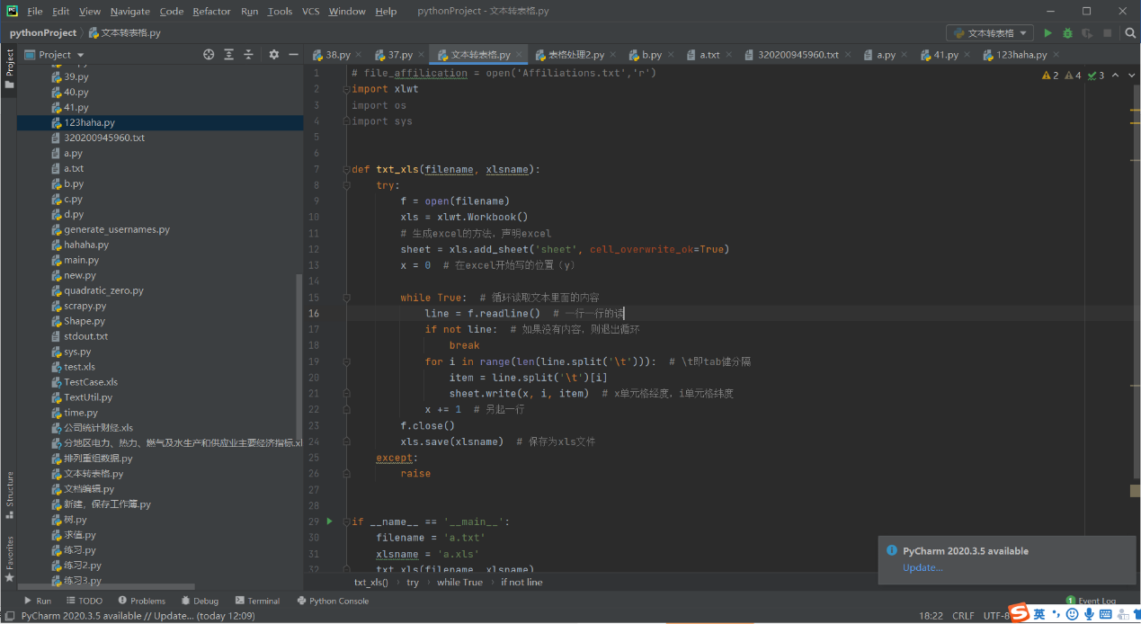

2. Excels -> Database

We consider changing the *.xls into data into database. Python allows us to do the work:

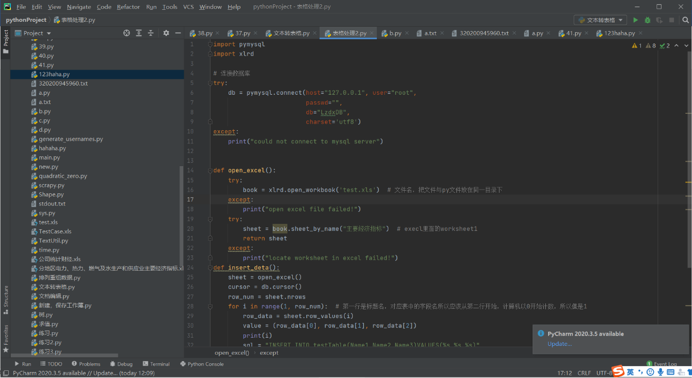

We can see the result of database:

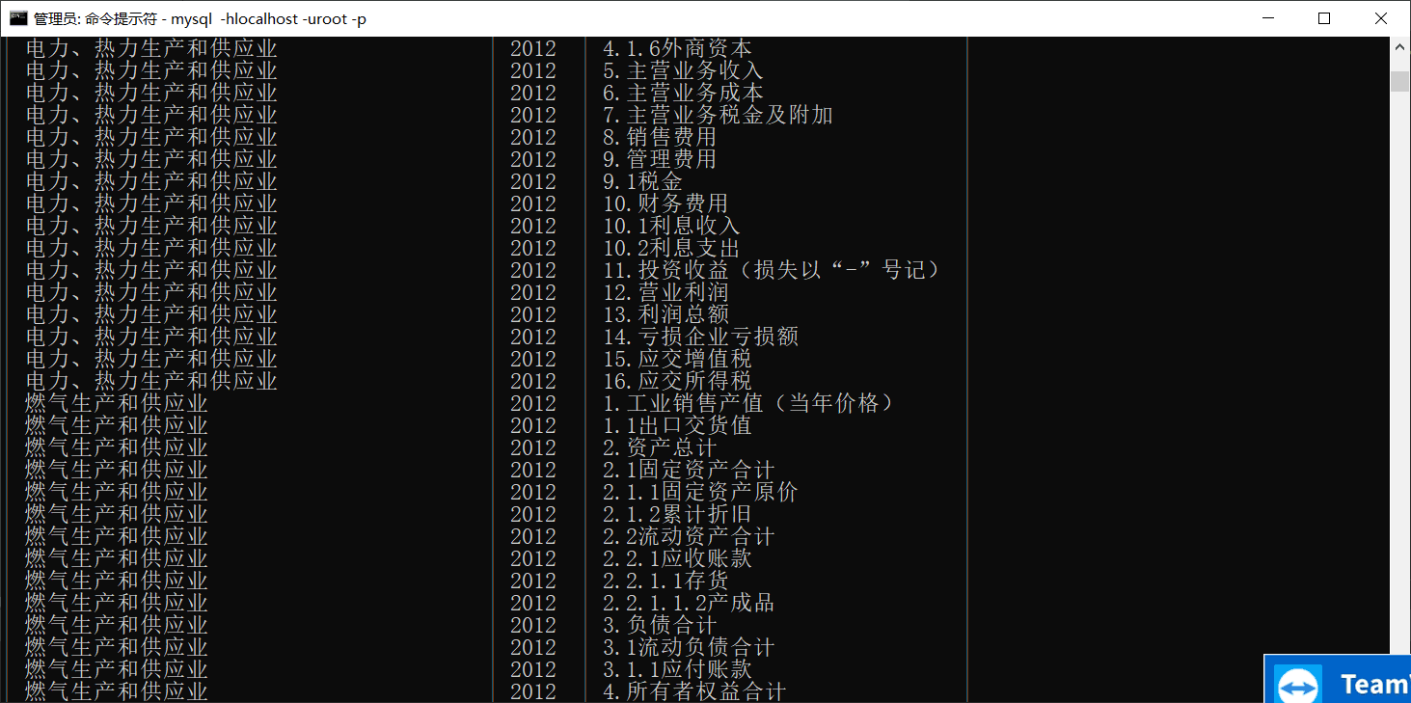

3. Create database

That’s what I am doing now: I divide the relational database into 6 areas:

Using the knowledge and technologies of database, we define the id, name, value of each areas.

**Resources:**

1. Data: We choose the data from the CNRDS to ensure the amount and the accuracy of data standards.

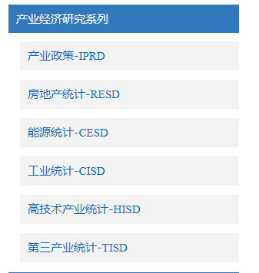

Also, we receive the data given by companies. It will be in the form of texts.

2. Database: MySQL, a database we have learnt about before, is a good choice to store local data.

3. API：

To connect website with MySQL, we need API.

**Project deliverables:**

1.<小标题不太会起>- Data storage

With the data inputted by the customers, we put it into database and divide it into major 6 parts:

1. Profitable index 2. Managing ability 3. Solvency index 4. Obeying the principles 5. Others

2.<小标题不太会起>- Data transfer

With the transfer of different areas of data, the data can be used for analysis. We create ER graph to determine the relationships of data. Also, basic attributes like the value, name, primary keys are defined into database.

**Expertise:**

1. Data exchanges

With the technologies inPython like xlrd and xlwt, we exchanges the data into specific types.

2. Data model creation

With the ER graph and database technologies we have, we are able to create the data relationship model.

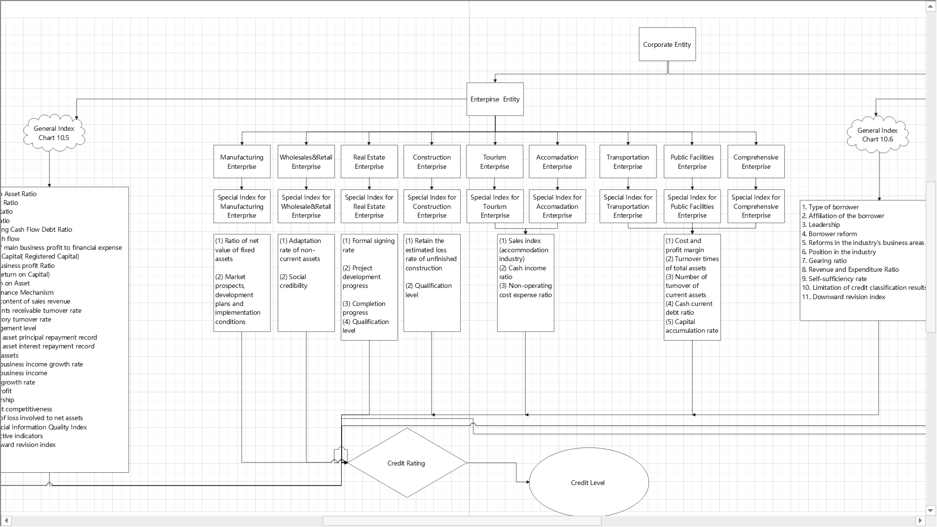

3. API

By learning how to use REST protocols, the connections of front-end and back-end are designed.

4. Data security

With the technologies of data security, we choose to add Asymmetric key encryption system.